 | 12.1.70 Editors - Geometry Nodes Editor - Header - Add Menu - Geometry Nodegroups - Grease Pencil - Write
Table of content
Detailed table of content 1
Add menu - Geometry nodes - Grease Pencil - Write 1
Set Screenspace Radius 2
Material Fill Info 2
Set Stroke / Fill Color 2
Set Stroke / Fill Opacity 2

Detailed table of content
Detailed table of content
Detailed table of content 1
Add menu - Geometry nodes - Grease Pencil - Write 1
Set Screenspace Radius 2
Material Fill Info 2
Set Stroke / Fill Color 2
Set Stroke / Fill Opacity 2

Add menu - Geometry nodes - Grease Pencil - Write

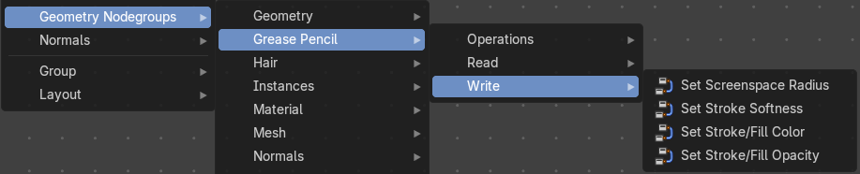
The nodes in this submenu are node groups. They use the regular single nodes under the hood.
It is virtually impossible to document these nodes in detail. So we will just list them.
When you double click the header, then you will enter the first level of the group. When you then press tab, or click again at the header, then you will reach the single nodes.




To leave the group you can use the breadcrumb up left in the header. These breadcrumbs are clickable. Or the Parent Node Tree button up right in the header.

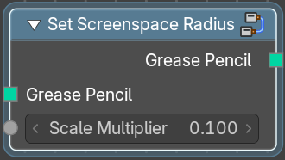
Set Screenspace Radius
Set the screenspace radius of the grease pencil.

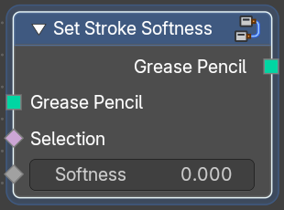
Material Fill Info
Set the stroke softness of the grease pencil.

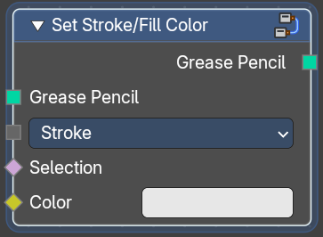
Set Stroke / Fill Color
Set the stroke fill color of the grease pencil.

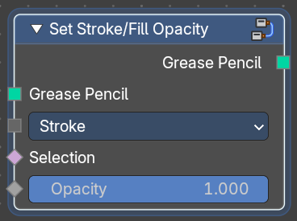
Set Stroke / Fill Opacity
Set the stroke fill opacity of the grease pencil.

